Analysis of Daily Hydropower Generation in India

(2023-2025)

Project Overview
A project involving the analysis of daily renewable energy generation focuses on leveraging data analytics and machine learning to understand, optimize, and forecast energy production from variable sources like solar and wind. The primary goal is to enhance efficiency, ensure grid stability, and maximize economic returns by making informed, data-driven decisions.

Project Objectives

Maximize Energy Output: Identify optimal operational strategies (e.g., solar tracking) and times of peak production to get the most out of installed capacity.

Improve Forecasting Accuracy: Develop models to predict future energy generation based on weather data, which helps in better grid integration and market participation.

Optimize Maintenance: Use predictive maintenance based on data anomalies to reduce operational costs and downtime.

Enhance System Integration: Facilitate the seamless integration of intermittent renewable sources with energy storage systems and traditional grids.

Data Sources:
  - Source Description and Timeline : Indian Data Portal (2019-2024) & Association of Daily Renewable Energy Generation(2023-2025)
  - Domain : Power Generation.

Problem Statement:

The primary problem is the unpredictability and fluctuation of wind speed and direction, which makes accurate power generation forecasting challenging.

The main challenge lies in the variable nature of sunlight availability, which is affected by weather conditions (cloud cover, rain) and the day-night cycle, leading to a mismatch between peak solar energy supply (midday) and peak demand times (morning and evening).

While some sources like geothermal and hydro are more stable, they still face unique data-related challenges, such as optimizing reservoir management for hydro, managing the complex supply chain and emissions for biomass, or efficiently assessing and managing geothermal reserves.

The overarching problem for total renewable energy integration is the safe and stable operation of a power system with a high penetration of diverse, variable, and distributed energy resources. This creates "peakiness" in supply and demand, leading to inefficient use of infrastructure and potential grid instability without adequate storage and transport capacity.

Attribute Details:

 | Attribute Name | Data Type | Description
 | ID | Integer | This is likely a unique identifier assigned to each record (e.g., each state's monthly report) within a specific database for tracking purposes.
 | DATE | Date | This attribute specifies the time frame for which the data is valid, typically the month and year of energy generation or the date the data was recorded/published.
 | State Name | Text | The full name of the Indian state or Union Territory
 | State Code | Text | A standardized short code or abbreviation for the state name, used for efficient data processing and storage
 | Region | Text | The broader geographical region the state belongs to (e.g., Northern Region (NR), Southern Region (SR), Western Region (WR), Eastern Region (ER), North Eastern Region (NER)).
 | Wind Energy | Decimal Number | The amount of energy generated or the installed capacity from wind power sources, typically measured in Megawatts (MW) for capacity or Million Units (MU)/Gigawatt-hours (GWh) for generation. This usually involves energy harnessed by wind turbines.
 | Solar Energy | Decimal Number | The amount of energy generated or the installed capacity from solar power sources, measured in MW or MU/GWh. This includes generation from ground-mounted and rooftop solar panels.
 | Other Renewable Energy | Decimal Number | This category encompasses energy from other renewable sources not classified as just wind or solar, such as:Biomass (bagasse cogeneration, non-bagasse cogeneration),Small Hydro Power (SHP),Waste to Energy.
 | Total Renewable Energy | Decimal Number | The aggregate sum of energy generated or installed capacity from all specified renewable energy sources for the given date and state (in MW or GWh).

Tools and Technologies:

Microsoft Excel:
Used Excel ETL Tool Power Query for initial data collection, cleaning, and transformation. Performed data consolidation, removal of duplicates, and preparation of consistent formats before importing into Power BI.

Microsoft Power BI:
The primary tool for data modelling, analysis, and dashboard creation. DAX (Data Analysis Expressions) was used to build custom measures and KPIs, while Power Query Editor handled data transformation and integration.

Data Preprocessing (Excel/Preprocessing)

Data Collection:
Collected Daily Renewable Energy data for the years 2019–2025 from the Indian Data Portal and 2023– 2025 data from Power source, where monthly data was stored in separate Excel sheets.

Data Consolidation:
Combined all monthly Excel sheets (2023–2025) into a single Excel workbook and removed subtotal and description rows for consistency.

Automation Using Macros:
Used Excel Macros Recording to automate repetitive formatting tasks such as column alignment, text formatting, and style standardization across all sheets.

Data Cleaning in Power Query:
Imported the datasets into Power Query Editor in Power BI to perform cleaning operations — filled empty cells using the Fill Down feature, standardized text formats, and ensured uniform data types.

Data Transformation:
Added a calculated flag column for better classification and applied consistent formulas and field names to align both datasets ( 2023–2025).

Data Integration:
Appended the cleaned and formatted datasets from both time periods to create a unified dataset covering 2019–2025, ready for visualization and analysis.

Data Modelling and DAX (Power BI)
Data Modelling: In data modelling, a Calendar Table was created and linked to the main dataset using the Date field to enable time-based analysis and trend visualization
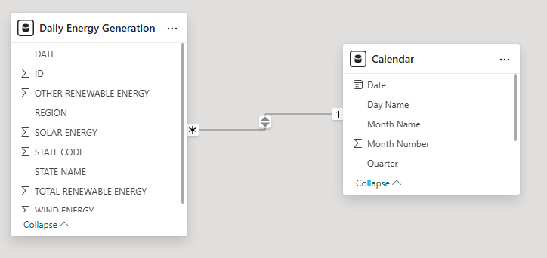

Calculated Columns, Calculated Table and DAX Measures:
Using DAX (Data Analysis Expressions), several calculated columns, Calculated Table, Measures were created to enhance analytical insights.
DAX Components Created:

Calculated Columns
    - Region and State

Calculated Table
    - Calendar Table
    - Measured Table

Measures:
    - Total Wind, Solar, Other Renewable Energy
    - Total Wind, Solar, Other Renewable Energy by Region
    - Total Wind, Solar, Other Renewable Energy by Year
    - YTD of Wind, Solar, Other Renewable Energy
    - Average of Wind, Solar, Other Renewable by year.

Analysis and Visualizations (PowerBI)
To address the identified problem statements, a series of interactive Power BI visualizations were developed. Various charts such as bar charts, line graphs, donut charts, tree maps, and KPI cards were used to analyse daily renewable energy generation –Wind, Solar, Other Renewable energy.
- To analyse Total wind Energy across different Region bar charts were used to identify the high energy generation and compare performance across Region.
- To analyse Average solar energy based on years(2023-2025) , a stacked area chart
was created to visualize total energy generate over years.
- To evaluate Other Renewable energy by Year and Quarter table visuals using Matrix table .
- To compare the performance of Wind Energy by Month using Line charts were utilized to represent and analyse differences every month energy generation.
- To identify which attract the most energy generation, a combination of slicers, Area Charts, funnel charts, and tree maps was used to provide interactive Region-wise analysis.
- To examine monthly and yearly AUM trends for forecasting Renewable Energy generation.
- To Analyse Total Solar energy by State Name using Map visualization.
- To Compare the Energy Generation by Month Name by using Scatter Chart, Ribbon chart, Donut Chart, Pie Chart was used to which month generate high energy produce.

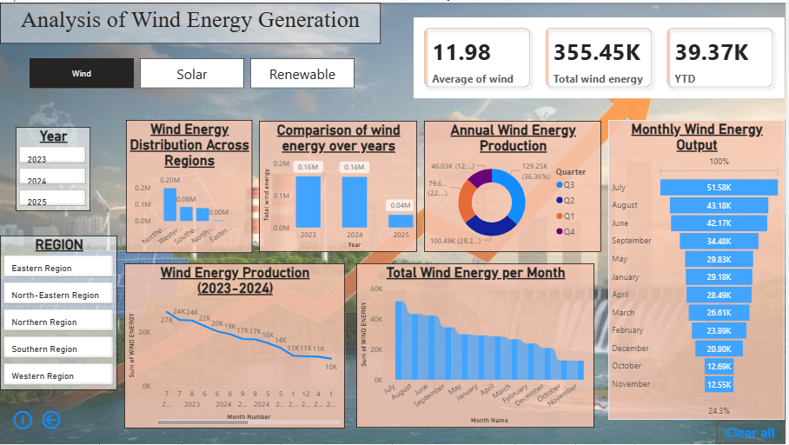
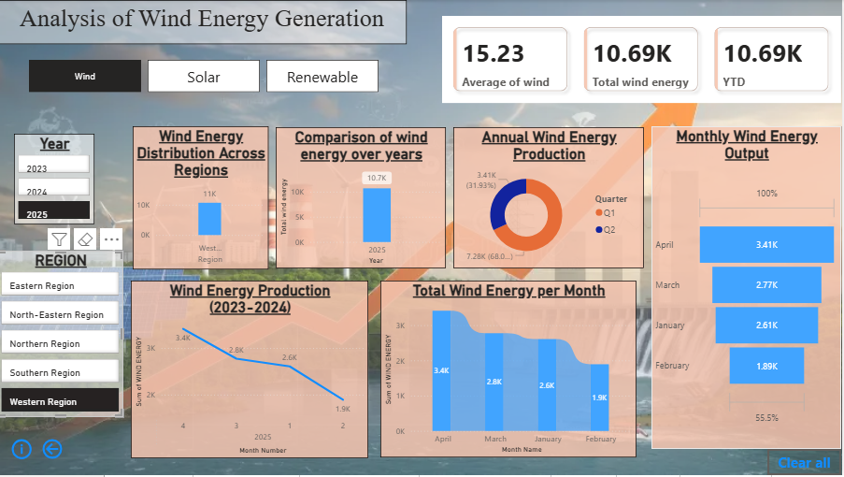

Insights of Wind Energy
- ﻿At 51,578.36, July had the highest Sum of WIND ENERGY and was 311.13% higher than November, which had the lowest Sum of WIND ENERGY at 12,545.66.﻿
- ﻿July accounted for 14.51% of Sum of WIND ENERGY.﻿
- ﻿Across all 12 Month Name, Sum of WIND ENERGY ranged from 12,545.66 to 51,578.36.﻿
- ﻿2024 in Month Number 7 made up 7.67% of Sum of WIND ENERGY.﻿

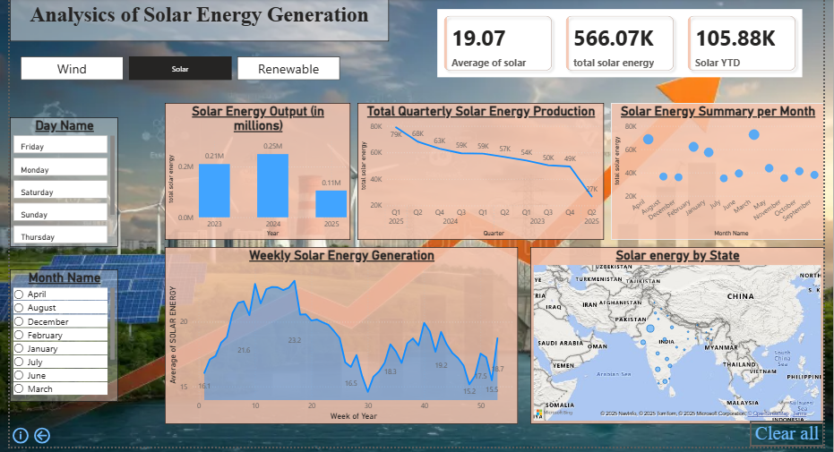
Insights of Solar Energy
- ﻿Q1 had the highest total total solar energy at 192,151.38, followed by Q2, Q4, and Q3.﻿
- ﻿2025 in Quarter Q1 made up 13.96% of total solar energy.﻿
- ﻿Q1 had the highest average total solar energy at 64,050.46, followed by Q4, Q3, and Q2.﻿
- ﻿At 249,712.20, 2024 had the highest total solar energy and was 135.85% higher than 2025, which had the lowest total solar energy at 105,877.98.﻿
- ﻿2024 had the highest total solar energy at 249,712.20, followed by 2023 at 210,478.49 and 2025 at 105,877.98.﻿
- ﻿2024 accounted for 44.11% of total solar energy.﻿
- ﻿2023 had 210,478.49 total solar energy, 2024 had 249,712.20, and 2025 had 105,877.98.﻿
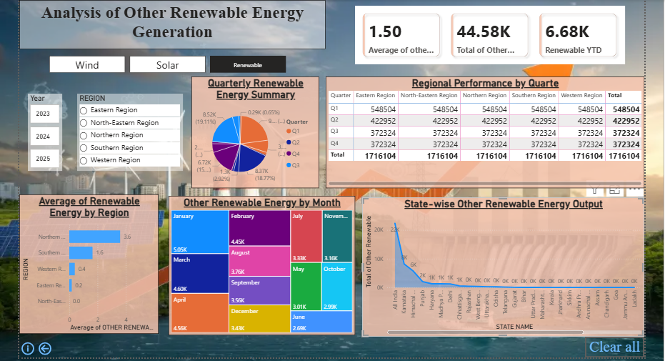

Insights of Other Renewable Energy
- ﻿At 3.59, Northern Region had the highest Average of OTHER RENEWABLE ENERGY and was Infinity higher than North-Eastern Region, which had the lowest Average of OTHER RENEWABLE ENERGY at 0.﻿
- ﻿Across all 5 REGION, Average of OTHER RENEWABLE ENERGY ranged from 0 to 3.59.﻿
- ﻿Q1 accounted for 39.25% of Eastern Region of other renewable energy.
- Total Capacity and Generation: India is the world's third-largest producer and consumer of electricity. In the fiscal year 2024-25, the country generated approximately 1,824 Billion Units (BU) of power.
- Dominant Energy Source: Thermal power, primarily coal, remains the backbone of the Indian power sector, providing essential baseload power. Coal accounts for over 50% of the total installed capacity and around 70% of the actual daily generation.
- Rapid Growth in Renewables: India is a global leader in renewable energy expansion and has already achieved its goal of having 50% of its installed electricity capacity from non-fossil fuel sources five years ahead of its 2030 target.
- As of June 2025, non-fossil sources contribute 235.7 GW (49% of total capacity).
- Based on State Wise Rajasthan has produce more solar energy = 12481 GW.
- Soaring Demand: Driven by economic growth, urbanization, and increasing per capita consumption, India's electricity demand is growing rapidly, at around 6-6.5% annually. Peak demand reached a record 250 GW in June 2025.
- Improved Reliability: Significant improvements in generation and transmission have 0.1% in 2024-25, indicating a more reliable power supply across the country.

Conclusion
The integration of Excel and Power BI enabled a complete analysis of the Indian Mutual Funds market from 2019 to 2025, covering Region, State Name, Wind Energy, Solar Energy, Other Renewable Energy and Total Renewable Energy. Data from multiple sources was cleaned, transformed, and modelled to create interactive dashboards for performance and trend analysis. The study revealed that daily renewable energy generation 2023 to 2025 reveals a period of rapid transition characterized by robust demand growth, a record surge in renewable energy. Overall, the project effectively turned complex power generation data into clear insights on more secure energy future, provided that grid and storage challenges are met.

